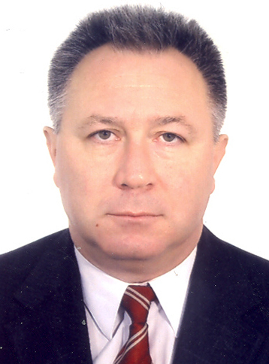 | MOSNEAGA Valeriu Gheorghe, 1955.  Republic of Moldova, Chişinău, Moldova State University, Faculty of International Relations, Political and Administrative Sciences. Head of the Chair of Political Science; Professor in Political Science, Doctor of Science.  Republica Moldova, Chisinau, MD-2009, str. Mateevici, 60.  Tel.: (373 22) 27-83-85, (373 22) 28-71-33;  Fax: (373-22) 24-42-48.
I am teaching courses in political parties, political marketing, and migrations. Till present I was supervisor for 1 post-doctoral dissertation, 8 doctoral dissertations in political science and 15 Master Degrees.

Research Interests: International migrations, Migrations in / from Republic of Moldova; Formation and activity of the multi-party system in Moldova, Electoral system and electoral technologies; Political modernization in transition societies.

I was a participant in many research projects in 1994-2010.
Financial support: Ford Foundation (USA), McArturs Foundation (USA), (Friedrich Ebert Foundation (Germany), International Organization of Migration, International Organization of Labor, UNESCO, Soros-Moldova Foundation, Moldavian Academy of Science, etc.

Author of more than 340 publications and among them 9 monographs: Republic of Moldova – migrations’ problems, 2007; Republic of Moldova: students as actor social-politic transformations, 2006; We build the Europe. But not only…, 2005; Independent Moldova and Migration, 1999; Republic of Moldova: parlamentary elections (1994) and political geography of electors, 1997; Political Power and social conflict (historical and politological research), 1997, etc)

Socially-scientific activity: I was the chairman of the organizing committee in more than 10 international symposiums, conferences and scientifically-practical seminars. Since 1992 - the managing editor of the scientific journal «MOLDOSCOPIE (Probleme de analiza politica (Problems of Political Analysis)» in the field of a political science, Republic Moldova, Chisinau (Kishinev). Since 2007 - chairman of a specialized Academic council on protecting of the doctor's dissertation in the field of political science. Since 2010 – the chairman of the Moldavian Association of the Political Science (MAPS)

LANGUAGE SKILLS:
(Fluent, Excellent, Good, Sufficient, Beginner, Poor)
Language | Speaking | Writing | Reading
English | S | S | G
Russian | F | F | F
Romanian | F | F | F

